A funny crossword about food and festivities...

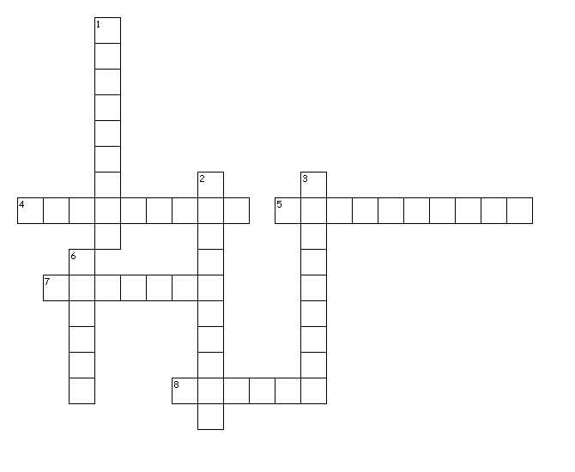
Across
4. Canadian celebrates their dead
5. typical British Columbia dish
7. uniquely Canadian food
8. Canadian eat it at Thanksgiving
Down
1. he foretells winter weather
2. often eaten with pancakes
3. 1st of July in Canada
6. famous Canadian beer

